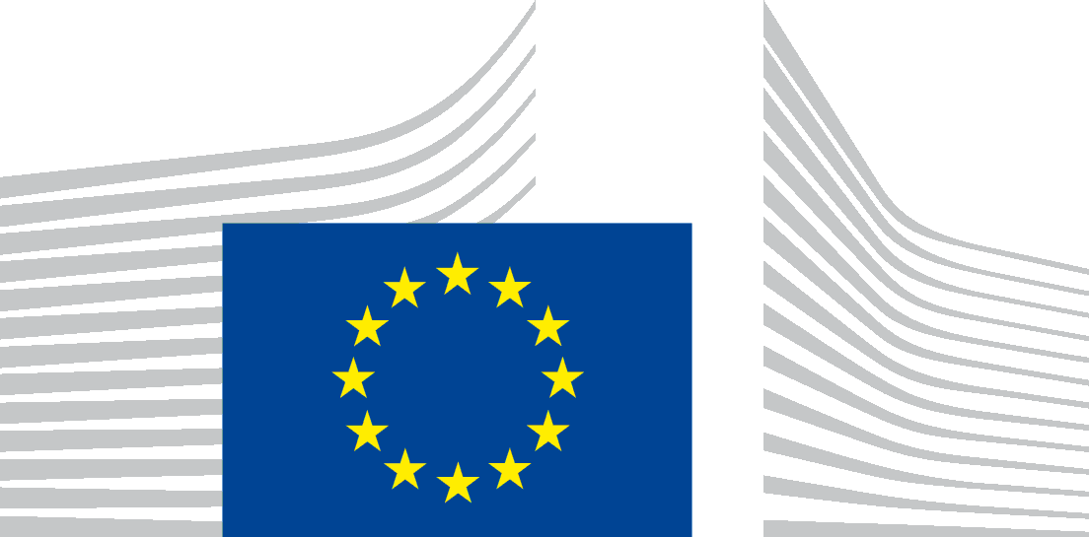 | EUROPEAN COMMISSION  DIRECTORATE-GENERAL  Directorate  Unit

Accessibility statement
This statement applies to content published on the domain:
https://ec.europa.eu/eurostat/cache/visualisations/energy-dashboard/endash.html
It does not apply to other content or websites published on any of its subdomains. These websites and their content will have their own specific accessibility statement.
This interactive tool is managed by Eurostat. It is designed to be used by as many people as possible, including people with disabilities.
You should be able to:
- zoom up to 200% without problems
- navigate the tool using just a keyboard
- navigate the tool using a modern screen reader and speech recognition software (on your computer or phone)
This interactive tool is designed to comply with the technical standard for websites and mobile apps, EN 301 549, v.3.2.1. This closely follows level ‘AA’ of the Web Content Accessibility Guidelines (WCAG) version 2.1.

Compliance status
This interactive tool is partially compliant with technical standard EN 301 549 v.3.2.1 and the Web Content Accessibility Guidelines (WCAG) 2.1 Level AA. See ‘Non-accessible content’ for more details.
The interactive tool was last tested on 16/07/2026.

Preparation of this statement
This statement was reviewed on 27/07/2026.
For this interactive tool the statement is based on a review using automated testing.

Feedback
We welcome your feedback on the accessibility of the Eurostat website. Please let us know if you encounter accessibility barriers:
- Phone: +352 4301 33 408
- E-mail: ESTAT-USER-SUPPORT@ec.europa.eu
- Contact form: multilingual user support page
We try to respond to feedback within 15 business days from the date of receipt of the enquiry by the responsible Commission department.
Compatibility with browsers and assistive technology
The Energy dashboard visualisation tool website is designed to be compatible with the following most used assistive technologies:
- the latest version of Google Chrome and Apple Safari browsers;
- in combination with the latest versions of JAWS, NVDA, VoiceOver and TalkBack.

Technical specifications

The accessibility of the Energy dashboard visualisation tool website relies on the following technologies to work with the particular combination of web browser and any assistive technologies or plugins installed on your computer:
- HTML
- WAI-ARIA
- CSS
- JavaScript

Non-accessible content
Despite our best efforts to ensure accessibility of the Energy dashboard visualisation tool website, we are aware of some limitations, which we are working to fix. Below is a description of known limitations and potential solutions. Please contact us if you encounter an issue not listed below.
Known limitations for the Energy dashboard visualisation tool website:
- Interactive tools / visualisations: The interactive tools and visualisations on this site do not always have text alternatives. We are aware that this is inaccessible for people using the screen reader or keyboard. However, all visualisations provide a direct link to the source dataset to display the data in table format.
- Automatically generated, downloadable documents in PDF format are not fully accessible.
- The tool is optimized for standard screen sizes, the user experience may be degraded on smaller displays (mobile phones and similar devices).

